**Experimental Graph:**

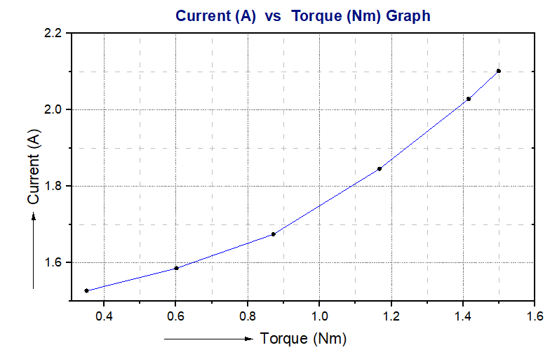

**Figure 01: Current versus Torque Graph for Single phase Motor**

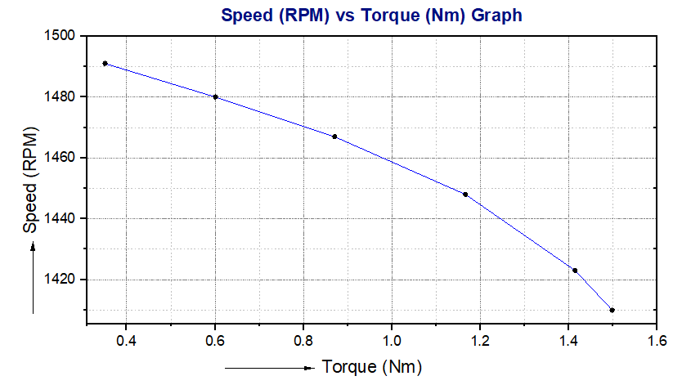

**Figure 02: Speed versus Torque Graph for Single phase Motor**

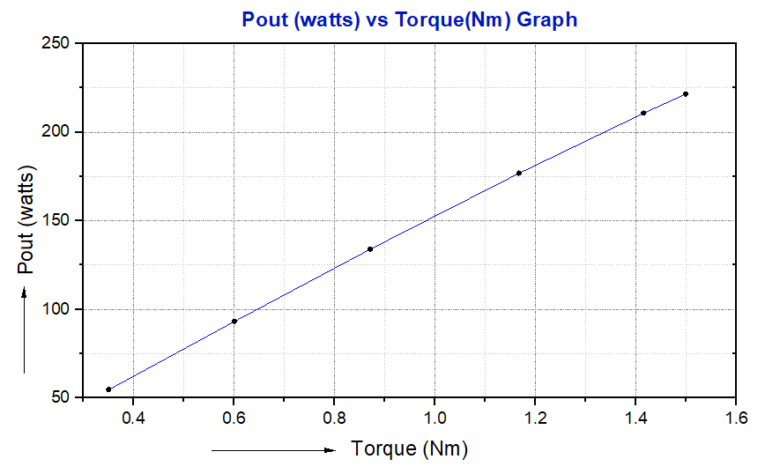

**Figure 03: Output power versus Torque Graph for Single phase Motor**

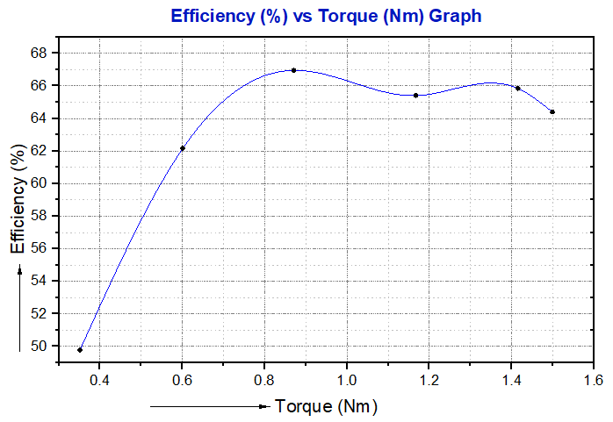

**Figure 04: Efficiency versus Torque Graph for Single phase Motor**